Async Await

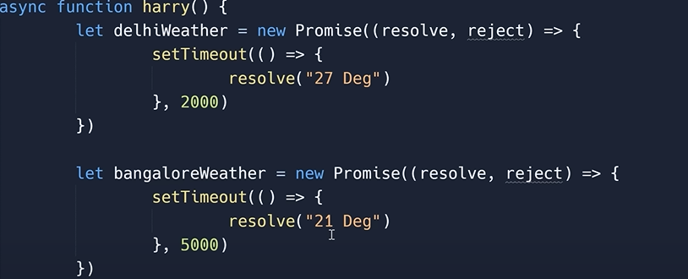

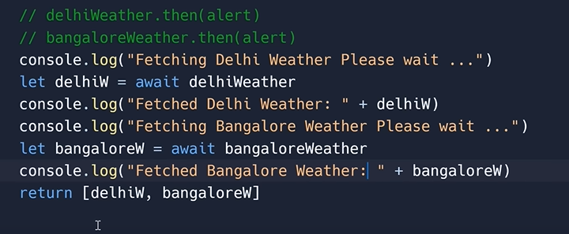

To stop the execution of the program

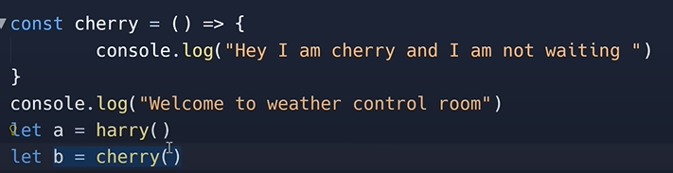

And another async fucntion will be executed parallely

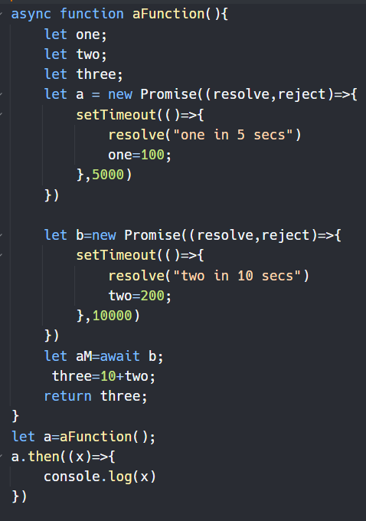

This is not possible with a normal function because the value of two will not be avalibaleto be calculated and added in variableThree

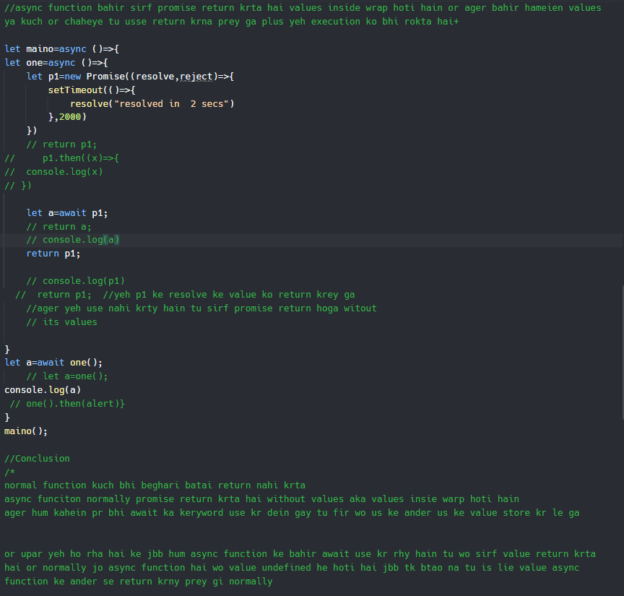

<https://replit.com/@Hasnain150/Async-Await>

<https://github.com/Hasnain150/notes/blob/main/AsyncAwait.js>

<https://youtu.be/bLre6Uf4Op0>